**Decision Tree**

**Example-iris Dataset**

**Model-1 🡺 Using function “ctree” from library “party”**

**Confusion Matrix 🡺**

Actual

Predicted setosa versicolor virginica

setosa 15 0 0

versicolor 0 17 1

virginica 0 0 12

**Accuracy of this model 🡺 0.977777**

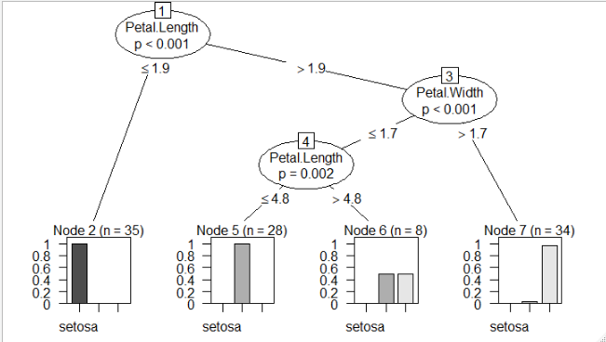

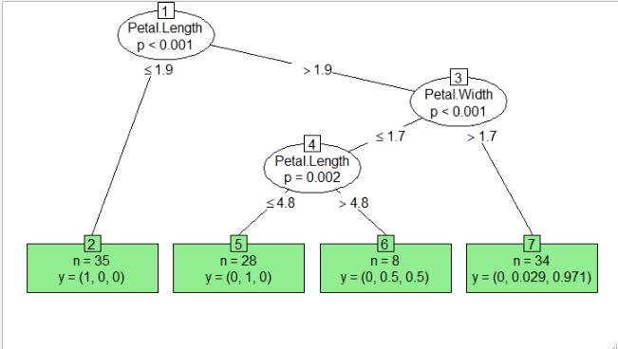

**Model-2 🡺 Using function “tree” from package “tree”**

**Confusion Matrix**

Actual

Predicted setosa versicolor virginica

setosa 15 0 0

versicolor 0 17 4

virginica 0 0 9

**Accuracy of this model 🡺 0.911111**

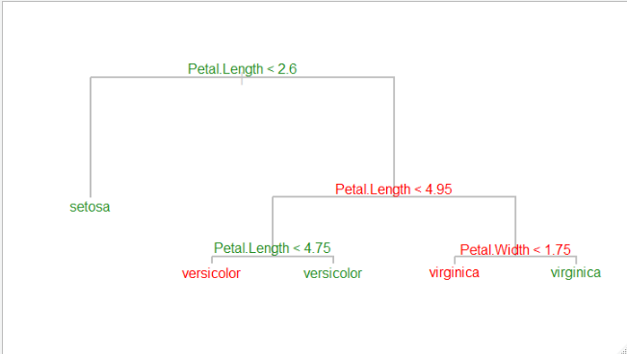

**This graph is better than the previous to view for lemma but unable to show probability within graph.**

**Also efficiency for this model is less than previous model.**

**Model-3 🡺 Using function “rpart” from package “rpart”**

**Confusion Matrix**

Actual

Predicted setosa versicolor virginica

setosa 15 0 0

versicolor 0 17 4

virginica 0 0 9

**Accuracy of this model 🡺 0.911111**

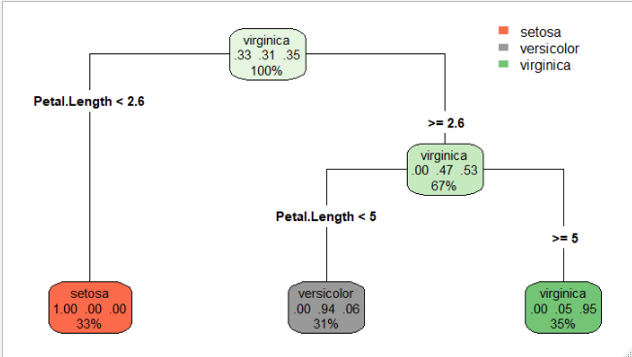

**Representation of graph is good but no improvement in accuracy.**

**Model-4 🡺 Using function “C5.0” from package “C50”**

**Confusion Matrix**

Actual

Predicted setosa versicolor virginica

setosa 15 0 0

versicolor 0 17 4

virginica 0 0 9

**Accuracy of this model 🡺 0.911111**

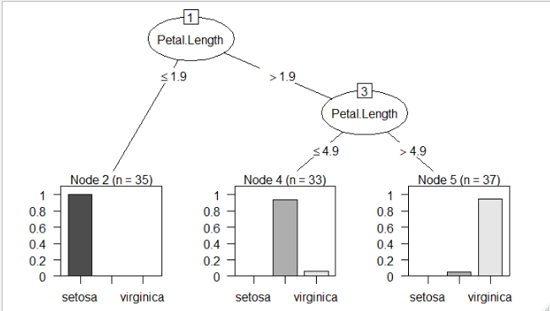

**This plot is similar like model with ctree function but difference is**

**with branches, here we can see that one branch and three leaf nodes.**

**Using Boosting Technique 🡺**

**Confusion Matrix**

predi5 setosa versicolor virginica

setosa 15 0 0

versicolor 0 17 1

virginica 0 0 12

**Accuracy 🡺0.97777**



**From the above information we can infer that boosted model with**

**C5.0 function is our best model.**